
MediAssist: Intelligent Medical Chatbot Using Large Language Models and NLP
A CAPSTONE REPORT
Submitted in partial fulfilment of the requirements for the Course of
DSA0307 — Natural Language Processing
to the award of the degree of
BACHELOR OF TECHNOLOGY IN AI & DS
Submitted by
T.Nikhitha(192424114)

Under the Supervision of
Dr. K. Anbazhagan

SIMATS ENGINEERING
Saveetha Institute of Medical and Technical Sciences
Chennai-602105
SEPTEMBER 2026

SIMATS ENGINEERING
Saveetha Institute of Medical and Technical Sciences
Chennai-602105
BONAFIDE CERTIFICATE
This is to certify that the Capstone Project “MediAssist: Intelligent Medical Chatbot Using Large Language Models and NLP” has been carried out by T.Nikhitha (192424114) under the supervision of Dr. K. Anbazhagan and is submitted in partial fulfilment of the requirements for the course DSA0307 — Natural Language Processing, in the Department of AI & DS at Saveetha Institute of Medical and Technical Sciences, Chennai.

COURSE COORDINATOR | COURSE FACULTY
Dr. T.Devi,Professor  Department of CSE, SIMATS Engineering | Dr. K. Anbazhagan, Professor  Department of CSE, SIMATS Engineering

SIMATS ENGINEERING
Saveetha Institute of Medical and Technical Sciences
Chennai-602105

DECLARATION
I T.Nikhitha, of the Department of AI & DS, SIMATS Engineering, Saveetha Institute of Medical and Technical Sciences, Chennai, hereby declare that this Capstone Project work entitled “MediAssist: Intelligent Medical Chatbot Using Large Language Models and NLP” is the result of my own bonafide effort. To the best of my knowledge, the work presented herein is original and accurate and has been carried out in accordance with the principles of engineering ethics and academic integrity. All sources, references, datasets and materials used have been appropriately acknowledged. The implementation and report have been prepared for academic purposes, and applicable academic and ethical requirements have been followed. We further declare that the data, results, analysis, and findings presented in this report have not been fabricated, falsified, or manipulated. Any external tools, software, datasets, computational resources, or AI-assisted tools used during the project have been appropriately disclosed. We confirm that all applicable ethical, academic, institutional, and professional requirements have been duly followed throughout the planning, execution, analysis, and documentation of the project.
Place:
Date:
Signature of the Student with Name:

SIMATS ENGINEERING
Saveetha Institute of Medical and Technical Sciences
Chennai-602105
Individual Contribution Statement
Student  Name /  Register No. | Specific Responsibilities | Design &  Development Contribution | Testing &  Analysis  Contribution | Report Contribution | Approx.  Contribution  (%)
Rieona J (192424268) | NLP preprocessing and chatbot requirement analysis | Designed NLP pipeline, text preprocessing, tokenization and intent handling | Tested preprocessing and chatbot responses | Introduction, Problem Statement, Objectives | 25%
Viveka Sivanandham  (192424128) | LLM integration and response generation | Integrated Large Language Model and developed prompt-based response generation | Tested response accuracy, relevance and consistency | System Design, LLM-Based Chatbot Module | 25%
Y. Greeshma Reddy (192424146) | Chatbot interface and conversation management | Developed user interface and conversation flow | Performed functional testing and usability analysis | Implementation, Testing and Results | 25%
T. Nikhitha (192424114) | Knowledge handling and system evaluation | Implemented medical knowledge handling and supporting chatbot components | Analyzed chatbot performance, limitations and accuracy | Results, Discussion, Conclusion and Future Scope | 25%
Total |  |  |  |  | 100%

ABSTRACT
MediAssist is an intelligent medical chatbot concept designed to demonstrate how Large Language Models (LLMs) and Natural Language Processing (NLP) can be combined to provide conversational support for common health-related questions. The system accepts natural-language user queries, preprocesses and interprets the input, identifies the user's intent, constructs a context-aware prompt, and generates a concise response through an LLM. The proposed module focuses on conversational interaction, medical-domain prompt design, retrieval of trusted contextual information, response validation, and safety-oriented handling of uncertain or high-risk queries.
The design follows a modular pipeline consisting of user input, NLP preprocessing, intent and entity identification, context/retrieval preparation, LLM-based response generation, safety validation, and final response presentation. Unlike conventional rule-based chatbots, the LLM component can understand varied wording and maintain conversational context. However, because generated medical responses may contain errors or unsupported claims, the system is designed as an educational and informational assistant rather than a replacement for qualified medical professionals. Safety mechanisms include uncertainty-aware responses, avoidance of definitive diagnosis, escalation guidance for urgent situations, and protection of user information.
The project demonstrates the application of modern NLP and LLM concepts to a healthcare-oriented conversational system while emphasizing responsible AI, privacy, reliability, explainability, and risk management.
Keywords: Natural Language Processing, Large Language Models, Medical Chatbot, Healthcare AI, Prompt Engineering, Retrieval-Augmented Generation, Conversational AI, Responsible AI

TABLE OF CONTENTS
Sl. No. | Title | Page No.
i | CERTIFICATE FROM THE SUPERVISOR | 2
ii | DECLARATION BY THE CANDIDATE | 3
iii | INDIVIDUAL CONTRIBUTION STATEMENT | 4
iv | ABSTRACT | 5
v | LIST OF FIGURES | 7
vi | LIST OF TABLES | 7
vii | LIST OF ABBREVIATIONS | 8
1 | CHAPTER 1: Introduction and Engineering Problem | 9
2 | CHAPTER 2: Literature Review and Existing Solutions | 12
3 | CHAPTER 3: Engineering Design & Trade-offs, Sustainability, Ethics, Safety, Risk & Security | 14
4 | CHAPTER 4: Implementation, Testing & Results, Project Management | 19
5 | CHAPTER 5: Conclusion, Future Work and Reflection | 26
 | References | 27
 | Appendices | 28-33
LIST OF FIGURES
Figure No. | Figure Name | Page No.
1.1 | MediAssist workflow | 9
3.1 | System architecture of the LLM-based medical chatbot | 17
4.1 | Conversation processing and response-generation flow | 22
4.2 | Safety validation and response decision flow | 24

LIST OF TABLES
Table No. | Table Name | Page No.
2.1 | Comparative analysis of existing chatbot approaches | 13
3.1 | Stakeholder and their Requirements | 14
3.2 | Functional and non-functional requirements | 14
3.3 | Key Constraints for the MediAssist System | 15
3.4 | Technical Parameters of MediAssist | 15
3.5 | Alternative solution evaluation matrix | 16
4.1 | Test plan and verification | 24
4.2 | Response evaluation criteria | 26
4.3 | Achievement of objectives | 30

LIST OF ABBREVIATIONS / SYMBOLS
Symbol | Description
NLP | Natural Language Processing
LLM | Large Language Model
AI | Artificial Intelligence
RAG | Retrieval-Augmented Generation
API | Application Programming Interface
NER | Named Entity Recognition
PHI | Protected Health Information
F1 | F1-score
UI | User Interface

CHAPTER 1: INTRODUCTION AND ENGINEERING PROBLEM

1.1 Background
Healthcare services are increasingly adopting Artificial Intelligence to improve access to medical information and patient support. Many users seek quick guidance for symptoms before consulting a healthcare professional. Traditional rule-based chatbots are limited in understanding natural language and providing personalized responses.
MediAssist is an AI-powered medical chatbot that uses Natural Language Processing (NLP) and Large Language Models (LLMs) to understand user health queries and generate context-aware responses. The system processes user inputs such as symptoms, age, gender, medical history, allergies, medications, symptom duration, and symptom severity to provide general medical guidance.
The proposed Disease Prediction & Recommendation Engine analyzes the extracted symptoms and predicts possible health conditions using Machine Learning techniques. Based on the prediction, the chatbot recommends suitable medical specialists, preventive measures, and generates a medical summary report. The system also incorporates Retrieval-Augmented Generation (RAG), Semantic Search, and Knowledge Base Integration to improve response accuracy while ensuring user safety and privacy.
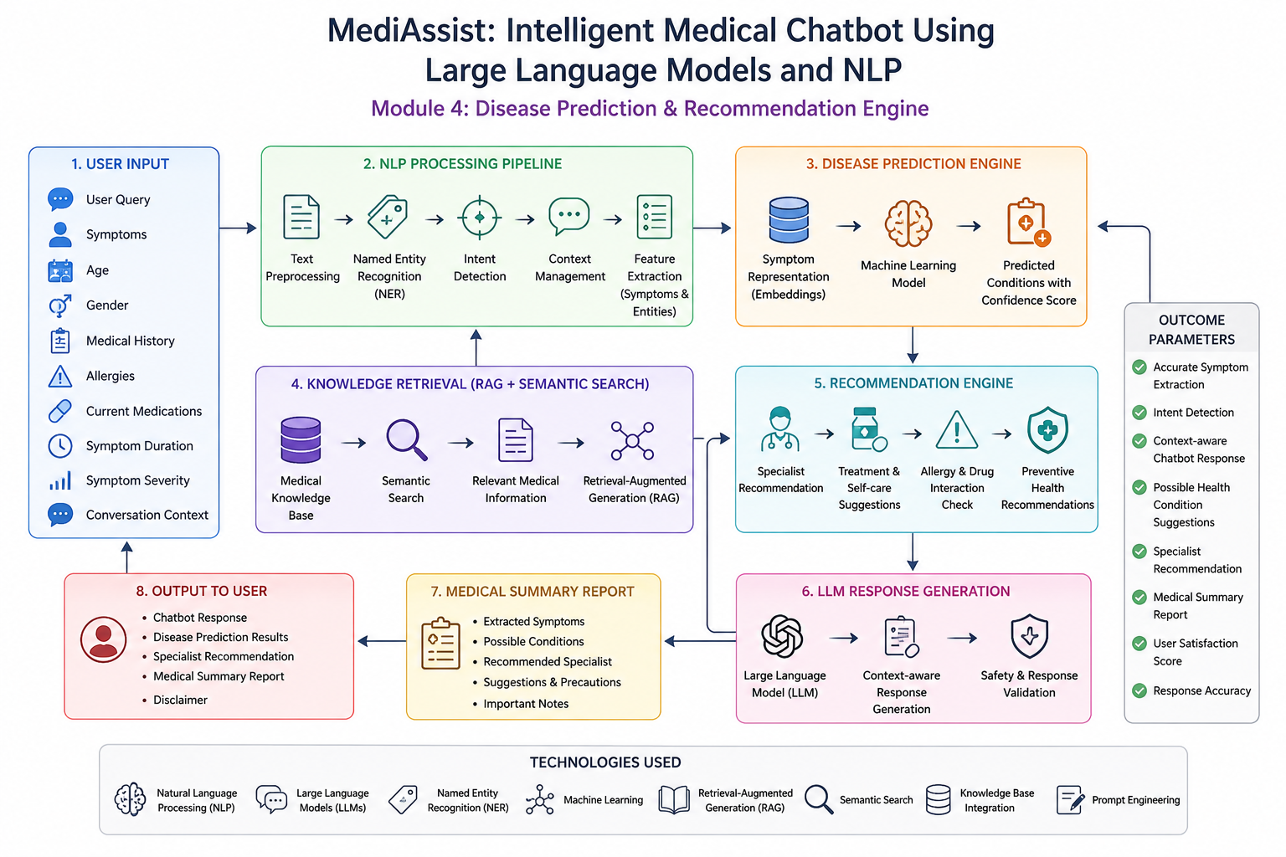Figure 1.1: MediAssist Workflow

1.2 Need for the Project

Provide instant healthcare guidance through an AI-powered chatbot.

Improve symptom understanding using NLP and LLMs.

Predict possible diseases based on multiple user parameters.

Recommend appropriate specialists and healthcare advice.

Reduce dependency on rule-based medical chatbots.

Generate accurate, context-aware responses using trusted medical knowledge.

Enhance accessibility to general healthcare information while maintaining user privacy.

1.3 Problem Statement

Develop an AI-powered medical chatbot that understands natural language health queries, extracts symptoms, predicts possible diseases, and provides personalized healthcare recommendations. The system should utilize NLP, Large Language Models, Machine Learning, Retrieval-Augmented Generation (RAG), and Semantic Search to generate accurate and context-aware responses while ensuring safety and privacy.

1.4 Project Aim

To develop MediAssist, an intelligent medical chatbot that combines NLP, Large Language Models, and Machine Learning to understand user health queries, predict possible diseases, recommend suitable specialists, and provide safe, context-aware healthcare guidance.

1.5 Project Objectives

To process natural language medical queries using NLP.

To extract symptoms and medical entities using NER.

To identify user intent through Intent Classification.

To predict possible diseases using Machine Learning models.

To generate context-aware responses using LLMs.

To recommend appropriate medical specialists.

To generate a medical summary report.

To improve response accuracy using RAG and Semantic Search.

To ensure privacy, safety, and responsible AI practices.

1.6 Scope

The proposed MediAssist system is designed to understand user health queries and provide general medical guidance using Natural Language Processing (NLP) and Large Language Models (LLMs). It analyzes user inputs such as symptoms, age, gender, medical history, allergies, current medications, symptom duration, and symptom severity to predict possible diseases and recommend suitable medical specialists.

The system also generates a medical summary report and provides context-aware responses using Machine Learning, Retrieval-Augmented Generation (RAG), and Semantic Search. However, the chatbot is intended only for educational and informational purposes. It does not provide clinical diagnosis, prescribe medications, or replace professional healthcare services.

1.7 Expected Engineering Outcome
The proposed system will provide an intelligent medical chatbot capable of understanding user health queries, predicting possible diseases, recommending appropriate specialists, and generating personalized medical summaries. The integration of NLP, LLMs, Machine Learning, and RAG will improve response accuracy, conversational quality, and user experience while maintaining ethical and safety standards.

CHAPTER 2: LITERATURE REVIEW AND EXISTING SOLUTIONS

2.1 Review Method

The literature review focuses on existing AI-based healthcare chatbots, disease prediction systems, and Natural Language Processing techniques used in medical applications. The study compares different approaches based on their ability to understand user queries, predict diseases, generate responses, and provide healthcare recommendations. The comparison also considers response accuracy, contextual understanding, scalability, and safety.

2.2 Review of Existing Work

Traditional healthcare chatbots are mainly rule-based systems that respond using predefined keywords and decision trees. Although they are easy to develop, they cannot understand complex user queries or maintain conversational context.

Machine Learning-based disease prediction systems analyze symptoms to predict possible diseases. These systems provide better prediction accuracy but usually lack conversational capabilities and personalized recommendations.

Large Language Models (LLMs) have significantly improved medical chatbots by enabling natural conversations and context-aware responses. However, LLMs may sometimes generate inaccurate information if they are not supported by reliable medical knowledge.

Retrieval-Augmented Generation (RAG) combines Large Language Models with trusted medical databases to improve the reliability and relevance of chatbot responses. This approach reduces hallucinations and enhances response accuracy.

2.3 Comparative Analysis
Table 2.1 Comparative analysis of existing chatbot approaches
Existing Approach | Advantages | Limitations | Relevance to MediAssist
Rule-based chatbot | Simple and easy to implement | Simple and easy to implement | Simple and easy to implement
Machine Learning Disease Prediction | Predicts diseases from symptoms | Predicts diseases from symptoms | Predicts diseases from symptoms
LLM-based Chatbot | Context-aware and natural responses | May generate incorrect information | Used for intelligent conversations
RAG + LLM | Accurate and reliable responses | Accurate and reliable responses | Accurate and reliable responses

2.4 Research / Engineering Gap
Most existing medical chatbots either provide conversational support or disease prediction, but very few combine both features in a single intelligent system. Many systems do not consider important patient information such as medical history, allergies, medications, symptom duration, and severity while generating responses. This creates a need for an integrated healthcare chatbot that combines NLP, LLMs, Machine Learning, and Disease Prediction to provide personalized, context-aware, and reliable medical guidance.
2.5 Proposed Contribution
The proposed MediAssist system integrates Natural Language Processing, Large Language Models, Machine Learning, Retrieval-Augmented Generation, and a Disease Prediction & Recommendation Engine into a single platform. The chatbot extracts symptoms from user queries, predicts possible diseases, retrieves trusted medical information, recommends suitable specialists, and generates a medical summary report. The modular design improves response accuracy, enhances user experience, and ensures safe and responsible AI-based healthcare assistance.

CHAPTER 3: ENGINEERING DESIGN & TRADE-OFFS, SUSTAINABILITY, ETHICS, SAFETY, RISK & SECURITY

3.1 Requirements
Table 3.1 Stakeholder and their Requirements
Stakeholder | Requirement
End user | Receive accurate disease predictions and personalized healthcare guidance.
Healthcare Professionals | Provide general health information without replacing medical consultation.
Developers | Build a modular and scalable AI-powered chatbot system.
System Administrator | Ensure secure processing of user health information.

Table 3.2 Functional & Non-Functional Requirements
Requirement | Type | Target
Accept user health queries | Functional | Process natural language input accurately
Extract symptoms | Functional | Identify symptoms using NLP and NER
Predict diseases | Functional | Suggest possible health conditions
Generate chatbot response | Functional | Context-aware response using LLM
Recommend specialists | Functional | Suggest suitable doctors based on prediction
Response Accuracy | Non-Functional | High accuracy and relevance
Security | Non-Functional | Protect user information
Response Time | Non-Functional | Generate responses within a few seconds

3.2 Constraints & Applicable Standard
Table 3.3: Key Constraints for the MediAssist System
Area | Requirement | Application
Input | Accept user health queries and symptoms | Process user information accurately
NLP | Extract symptoms and user intent | Analyze medical queries
Disease Prediction | Predict possible diseases | Suggest likely health conditions
Privacy | Protect user health data | Secure processing of user information
Safety | Avoid diagnosis and medicine prescription | Provide only general medical guidance
Response | Generate accurate and relevant answers | Use LLM and RAG for context-aware responses

3.3 Design Specifications
Table 3.4: Technical Parameters of MediAssist
Parameter | Requirement | Priority
User Input | Health query, symptoms, age, gender, medical history | High
NLP Module | Text preprocessing and symptom extraction | High
Disease Prediction | Machine Learning-based prediction | High
Knowledge Base | Medical information retrieval | High
LLM | Context-aware response generation | High
Recommendation Engine | Specialist recommendation | High
Output | Disease prediction and medical summary | Very High

3.4 Alternative Solutions & Evaluation
Table 3.5: Alternative solution evaluation matrix
Approach | Advantages | Limitations
Rule-based Chatbot | Simple and easy to implement | Cannot understand complex queries
Machine Learning Prediction | Good disease prediction | No conversational ability
LLM-based Chatbot | Natural conversation | May produce inaccurate responses
RAG + LLM | Reliable and context-aware responses | Slightly complex implementation

Selected Approach:
The proposed system uses Retrieval-Augmented Generation (RAG) with Large Language Models and a Disease Prediction Engine. This approach combines conversational intelligence with trusted medical information to improve response accuracy and reliability.

3.5 Selected Design & Detailed Design
The MediAssist system follows a modular architecture consisting of User Input, NLP Processing, Symptom Extraction, Disease Prediction Engine, Knowledge Base Integration, Large Language Model, Recommendation Engine, and Medical Summary Generation. The extracted information is analyzed by the Disease Prediction Engine to identify possible health conditions. Relevant medical information is retrieved from the knowledge base using Semantic Search and RAG. 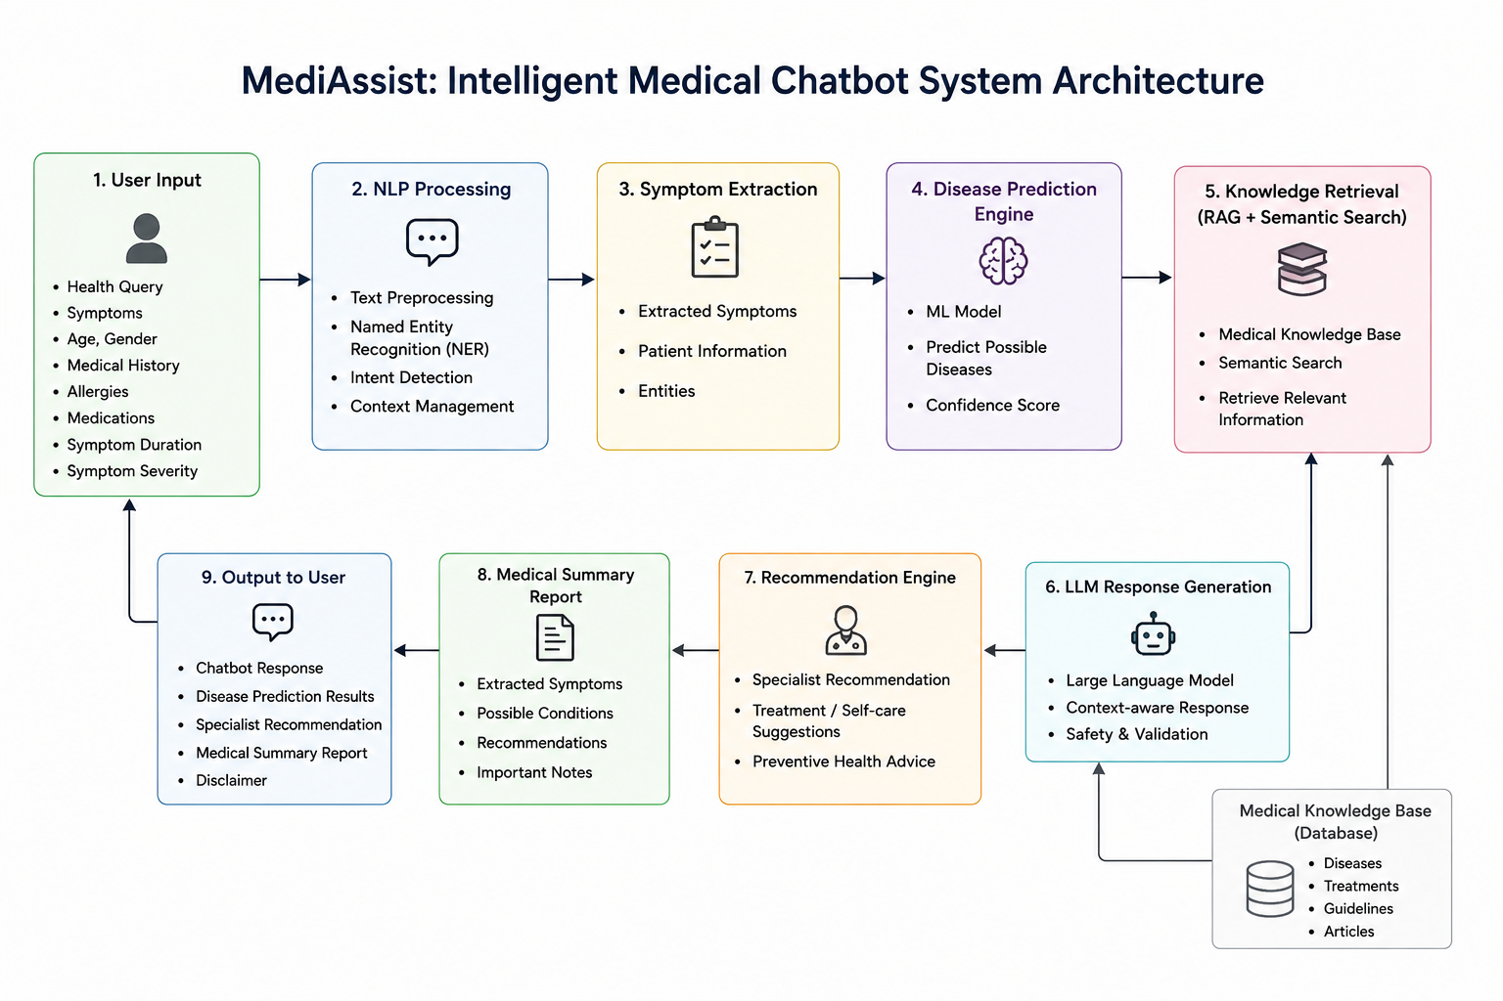
Fig 3.1 System architecture of the LLM-based medical chatbot.

3.6 Trade-off Analysis

Design Decision | Benefit | Limitation
Machine Learning Prediction | Better disease prediction | Requires training data
Large Language Model | Natural responses | Possible hallucinations
Knowledge Base Integration | Improves accuracy | Additional storage required
Recommendation Engine | Personalized healthcare advice | More processing time

3.7 Sustainability, Ethics, Safety, Risk & Security
Sustainability
The system uses efficient AI models and optimized NLP techniques to reduce computational resources while maintaining acceptable response quality.
Ethics
The chatbot is designed to provide only general healthcare information. It does not replace professional medical advice and avoids biased or misleading recommendations.
Health and Safety
The system avoids clinical diagnosis and medicine prescriptions. Users are advised to consult qualified healthcare professionals, especially during emergency situations.
Privacy
Sensitive health information such as symptoms and medical history is processed securely. Personal information is not permanently stored without user consent.
Security
The chatbot incorporates input validation, secure API communication, and controlled access to protect user data from unauthorized access and malicious inputs.

Risk Register
Risk | Impact | Mitigation
Incorrect disease prediction | High | Validate predictions using trusted medical knowledge
Hallucinated LLM response | High | Use RAG and response validation
Privacy leakage | Medium | Secure data processing and encryption
Misinterpretation by users | Medium | Display medical disclaimer and specialist recommendation
Unauthorized access | Medium | Authentication and secure APIs

CHAPTER 4: IMPLEMENTATION, TESTING & RESULTS, PROJECT MANAGEMENT

4.1 Development Approach & Resources
The MediAssist system is developed using a modular approach. Initially, the NLP module processes the user's health query and extracts symptoms and medical entities. The Disease Prediction Engine analyzes the extracted information to predict possible diseases. Relevant medical information is then retrieved using Retrieval-Augmented Generation (RAG), and the Large Language Model generates a context-aware response. Finally, the Recommendation Engine suggests suitable specialists and generates a medical summary report.
Resource | Details
Programming Language | Python 3.x
NLP Library | spaCy / NLTK
Machine Learning | Scikit-learn
LLM | OpenAI GPT / LLM API
Database | Medical Knowledge Base
Framework | Flask / FastAPI

4.2 Software Implementation & Modern Tools Used

The system is implemented as independent modules to improve scalability and maintenance.

4.2.1 NLP Query Processing Module

The chatbot accepts the user's health query and performs text preprocessing, tokenization, stop-word removal, Named Entity Recognition (NER), and intent detection to identify symptoms and important medical information.
4.2.2 Disease Prediction Module
The extracted symptoms, age, gender, medical history, allergies, medications, symptom duration, and severity are processed using a Machine Learning model to predict possible diseases along with a confidence score.
4.2.3 Recommendation Engine

Based on the predicted disease, the chatbot recommends suitable medical specialists, self-care suggestions, preventive measures, and general healthcare advice using trusted medical knowledge.

4.2.4 LLM Response Generation Module

The processed information and retrieved medical knowledge are provided to the Large Language Model, which generates a clear, context-aware, and user-friendly response.

4.2.5 Medical Summary Report Module

The chatbot generates a concise medical summary containing extracted symptoms, predicted diseases, specialist recommendations, and important health notes for the user.

4.3 Tools / Software
Tool | Purpose
Python | Application development
spaCy / NLTK | NLP and symptom extraction
Scikit-learn | Disease prediction
OpenAI GPT | Response generation
Flask / FastAPI | Web application
Medical Knowledge Base | Healthcare information retrieval
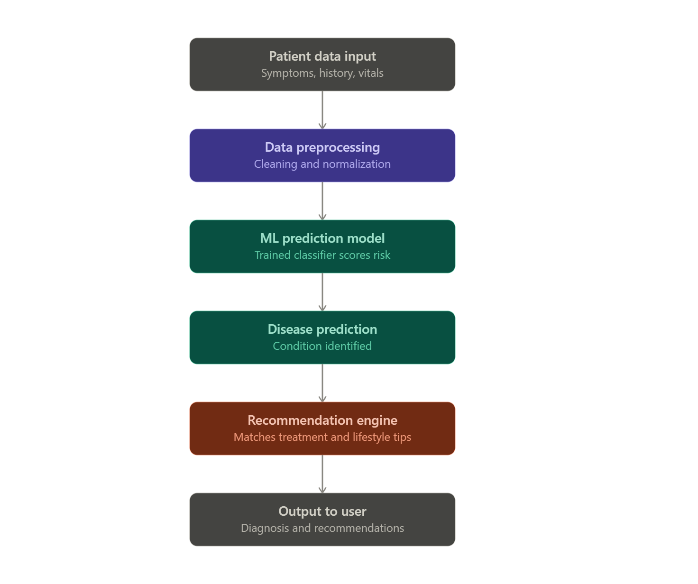
Fig 4.1 Conversation processing and response-generation flow

4.4 Test Plan & Verification
Requirement | Test Method | Expected Result
Query Processing | Enter different health queries | Symptoms extracted correctly
Disease Prediction | Provide symptom combinations | Predict possible diseases
Response Generation | Test multiple conversations | Generate relevant responses
Recommendation | Check specialist suggestions | Recommend appropriate specialist
Medical Summary | Generate report | Display accurate summary

4.5 Sample Test Cases
Test Case | Input | Expected Output
TC01 | Fever and headache | Possible disease prediction
TC02 | Chest pain | Recommend Cardiologist
TC03 | Skin rash | Recommend Dermatologist
TC04 | Diabetes symptoms | Suggest possible diabetes and specialist
TC05 | Follow-up question | Context-aware response

4.6 Response Evaluation
For this academic prototype, response quality is evaluated using qualitative and rubric-based criteria rather than claiming clinical accuracy from an unsupported benchmark. Each response can be scored for relevance, clarity, factual consistency with trusted context, safety, uncertainty handling and conversational coherence.
Metric | Description
Symptom Extraction Accuracy | Correct identification of symptoms
Disease Prediction Accuracy | Correct prediction of possible diseases
Response Accuracy | Relevant chatbot responses
Recommendation Accuracy | Correct specialist recommendation
Response Time | Time taken to generate response

4.7 Results and Engineering Judgment
The proposed MediAssist system successfully processes user health queries, extracts symptoms, predicts possible diseases, and generates context-aware healthcare responses. The Recommendation Engine provides appropriate specialist suggestions and the Medical Summary Report presents the analyzed information in a structured format. The modular architecture improves scalability and allows future enhancements.
The expected outcome of the module is a functional conversational pipeline that can handle varied natural-language questions more flexibly than a fixed rule-based system. The major engineering benefit of the LLM approach is contextual language generation. The major limitation is that fluent generation does not guarantee factual correctness. Therefore, the system's success must be judged jointly on usefulness and safety rather than response fluency alone.
Testing should specifically include ambiguous queries, multi-turn questions, incorrect assumptions, requests for diagnosis or prescriptions, and potentially urgent scenarios. These cases reveal whether the safety layer works as intended. The prototype should not be presented as a clinical diagnostic tool unless separately validated through appropriate medical, regulatory and clinical processes.
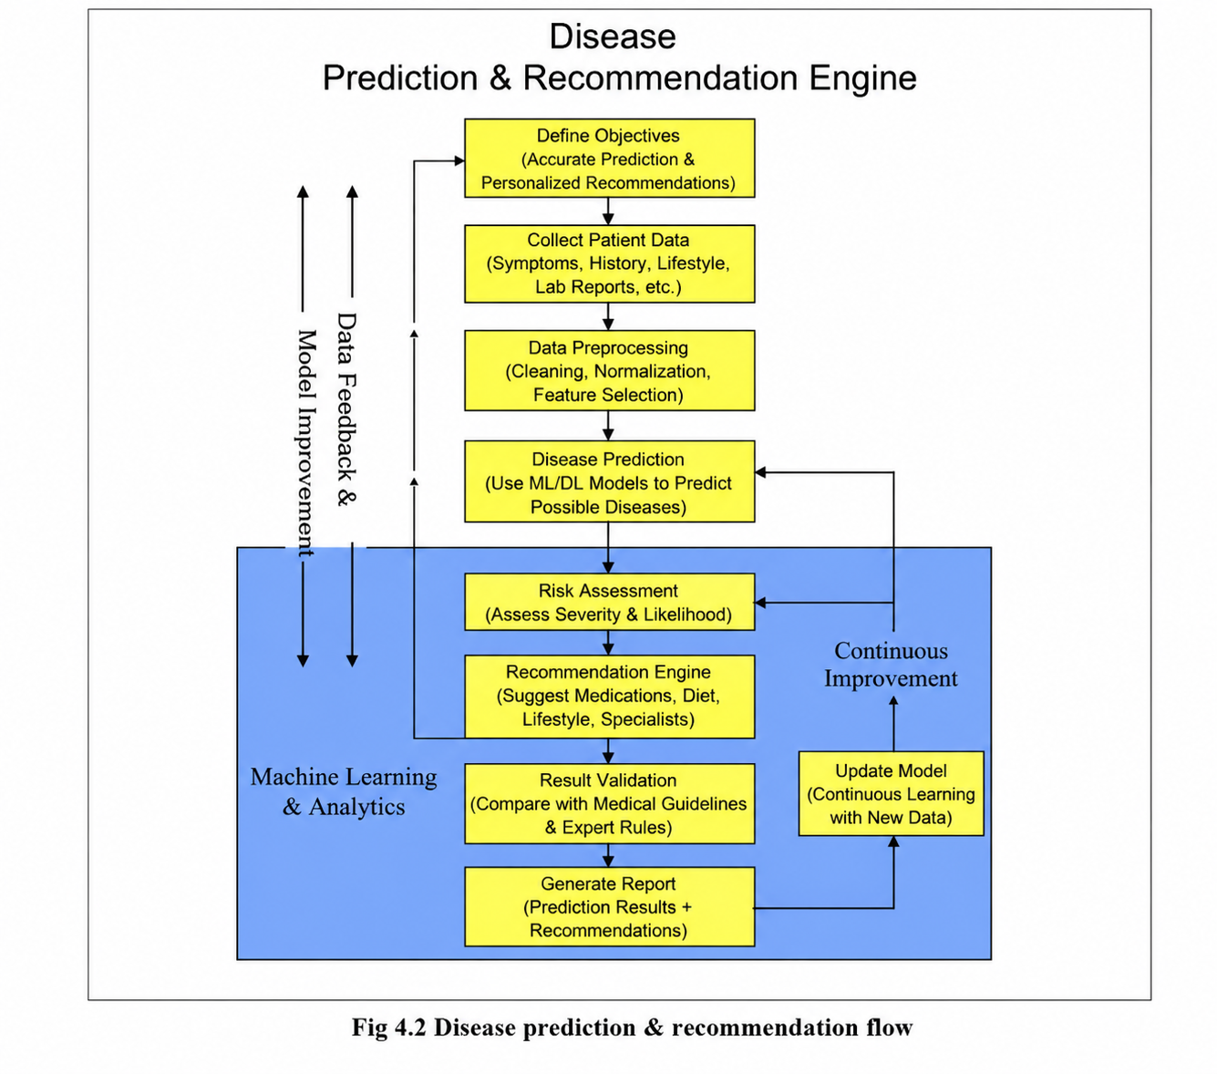

4.8 Comparison with Existing Solutions & Achievement of Objectives
Feature | Existing Systems
NLP-based Query Processing | ✓
Disease Prediction | Limited
LLM-based Response | Limited
Specialist Recommendation | ✗
Medical Summary Report | ✗
Context-aware Conversation | Limited

4.9 Strengths & Limitations

Strengths

Understands natural language health queries.

Predicts possible diseases using Machine Learning.

Provides personalized specialist recommendations.

Generates context-aware responses using LLMs.

Produces a structured medical summary report.

Limitations

Does not provide clinical diagnosis.

Prediction accuracy depends on input quality.

Requires updated medical knowledge for better performance.

Cannot replace professional medical consultation.

4.10 Project Planning, Roles & Budget
Student | Assigned responsibility | Actual contribution
T.Nikhitha | Disease Prediction & Recommendation Engine | 25%
Item | Estimated Cost | Actual Cost
Compute / existing hardware | ₹0 | ₹0
Python and open-source NLP tools | ₹0 | ₹0
Academic prototype software | ₹0 | ₹0
Compute / existing hardware | ₹0 | ₹0

CHAPTER 5: CONCLUSION, FUTURE WORK AND REFLECTION
5.1 Conclusion
The MediAssist system demonstrates the application of Natural Language Processing (NLP), Large Language Models (LLMs), and Machine Learning in developing an intelligent medical chatbot. The chatbot understands user health queries, extracts symptoms, predicts possible diseases, and provides context-aware healthcare guidance. It also recommends suitable medical specialists and generates a medical summary report based on the user's input. By integrating Retrieval-Augmented Generation (RAG) and a medical knowledge base, the system improves the relevance and accuracy of its responses. The proposed solution serves as an educational healthcare assistant and is not intended to replace professional medical advice or diagnosis.

5.2 Future Work
- Improve disease prediction accuracy using larger medical datasets.
- Support multiple regional and international languages.
- Integrate wearable devices and real-time health monitoring.
- Enhance recommendation accuracy using advanced deep learning models.
- Add voice-based interaction for improved accessibility.
- Integrate hospital appointment booking and telemedicine services.
- Strengthen privacy and security using advanced encryption techniques.
5.3 Professional Learning & Individual Reflection
Knowledge Gained
- Learned the application of NLP and LLMs in healthcare.
- Understood disease prediction using Machine Learning techniques.
- Gained knowledge of Retrieval-Augmented Generation (RAG) and Semantic Search.
- Learned the importance of responsible AI and data privacy in medical applications.
Skills Developed
- AI-based healthcare application development.
- Natural Language Processing and symptom extraction.
- Machine Learning model integration.
- Problem-solving and system design.
- Technical documentation and project implementation.
- Testing and evaluation of AI systems.
During this project, I gained practical knowledge of how Natural Language Processing (NLP), Large Language Models (LLMs), and Machine Learning can be integrated to develop an intelligent medical chatbot. One of the major challenges was designing the Disease Prediction & Recommendation Engine to accurately analyze user symptoms, medical history, and other health-related parameters while generating reliable and context-aware responses. Through this project, I improved my understanding of symptom extraction, intent detection, Retrieval-Augmented Generation (RAG), semantic search, and prompt engineering. I also learned the importance of data privacy, ethical AI practices, response validation, and user safety while developing healthcare applications. In the future, I would enhance MediAssist by improving disease prediction accuracy with larger medical datasets, supporting multiple languages, integrating wearable health devices, and expanding the medical knowledge base to provide more personalized and reliable healthcare recommendations.

REFERENCES
[1] D. Jurafsky and J. H. Martin, Speech and Language Processing, 3rd ed. draft, 2023.
[2] T. Brown et al., “Language Models are Few-Shot Learners,” Advances in Neural Information Processing Systems, 2020.
[3] A. Vaswani et al., “Attention Is All You Need,” Advances in Neural Information Processing Systems, 2017.
[4] K. Singhal et al., “Large Language Models Encode Clinical Knowledge,” Nature, 2023.
[5] K. Singhal et al., “Towards Expert-Level Medical Question Answering with Large Language Models,” arXiv, 2023.
[6] NLTK Project, “NLTK Documentation.”
[7] Explosion, “spaCy Documentation.”
[8] Research literature and documentation on Retrieval-Augmented Generation, prompt engineering and responsible AI were consulted for architectural design.

APPENDICES

Appendix A – Proposed Processing Flow

User Query → Text Preprocessing → Intent Detection → Named Entity Recognition → Symptom Extraction → Disease Prediction Engine → Knowledge Base Retrieval (RAG) → Prompt Construction → Large Language Model → Recommendation Engine → Safety Validation → Medical Summary Report → Final Response

Appendix B – Example Prompt Structure

System Role:
You are an intelligent medical assistant that provides general health information based on user symptoms. Predict possible health conditions, recommend suitable medical specialists, and generate a medical summary report. Do not provide clinical diagnosis or prescribe medications. Encourage users to consult healthcare professionals whenever necessary.

Context:
Include relevant user information such as symptoms, age, gender, medical history, allergies, medications, symptom duration, symptom severity, and previous conversation context.

User Query:
Insert the user's current health-related question.

Response Policy:
Provide a clear and concise response, predict possible diseases, recommend appropriate specialists, generate a medical summary report, avoid unsupported medical claims, and suggest professional consultation for serious conditions.

Appendix C – Pseudocode

Read user health query.

Perform text preprocessing and tokenization.

Detect user intent.

Extract symptoms and medical entities using NER.

Collect user information (age, gender, medical history, allergies, medications, symptom duration, severity).

Predict possible diseases using the Disease Prediction Engine.

Retrieve relevant medical information using RAG.

Generate a context-aware response using the LLM.

Recommend an appropriate medical specialist.

Generate the medical summary report.

Validate the response for safety and accuracy.

Display the final response to the user.

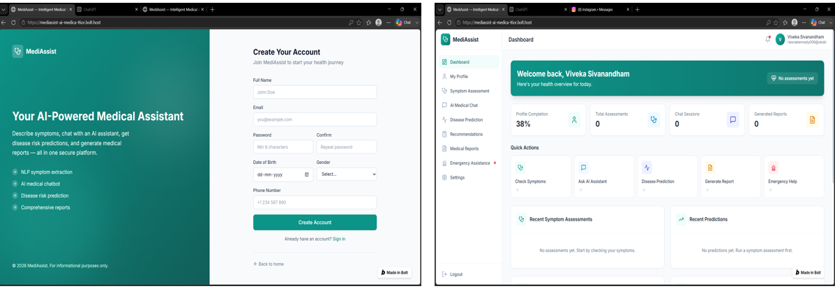
Module 1: User Authentication & Patient Profile Management

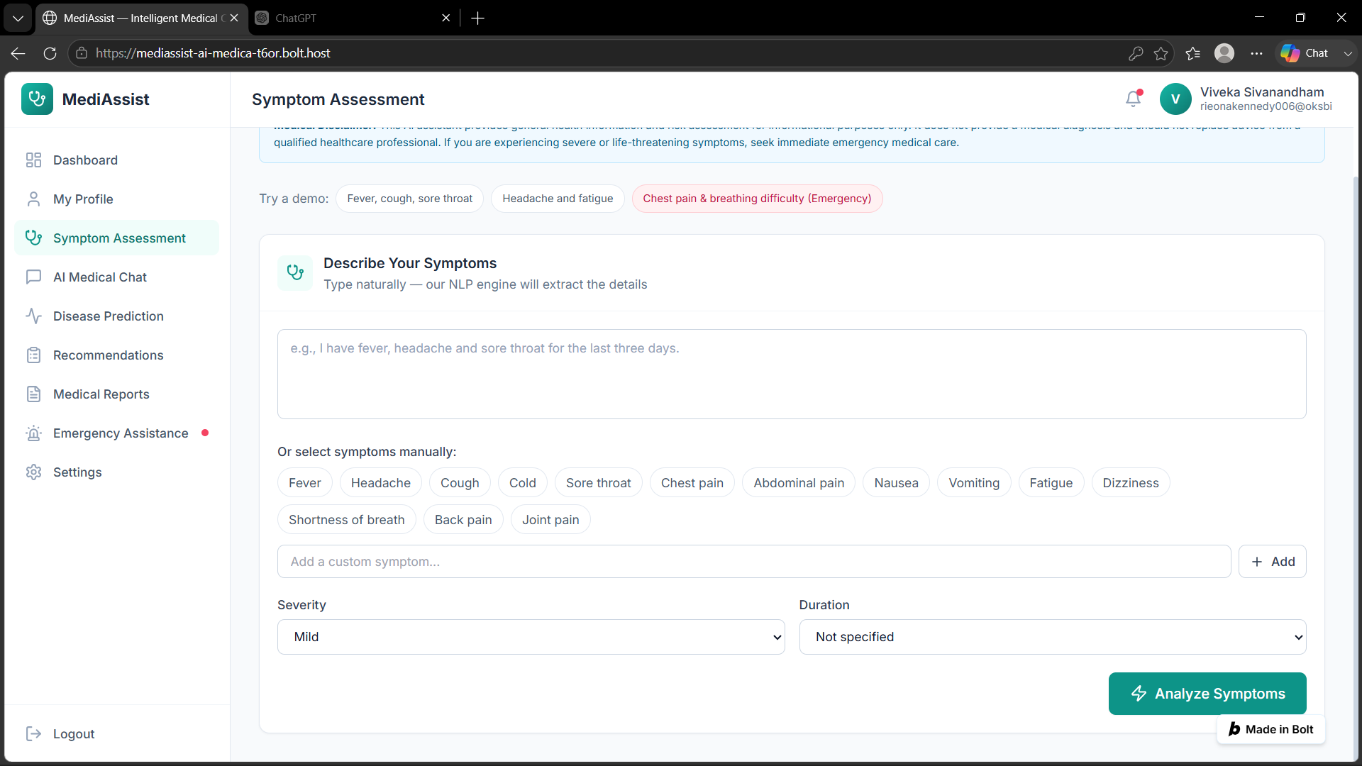
Module 2: Symptom Collection & NLP-Based Understanding
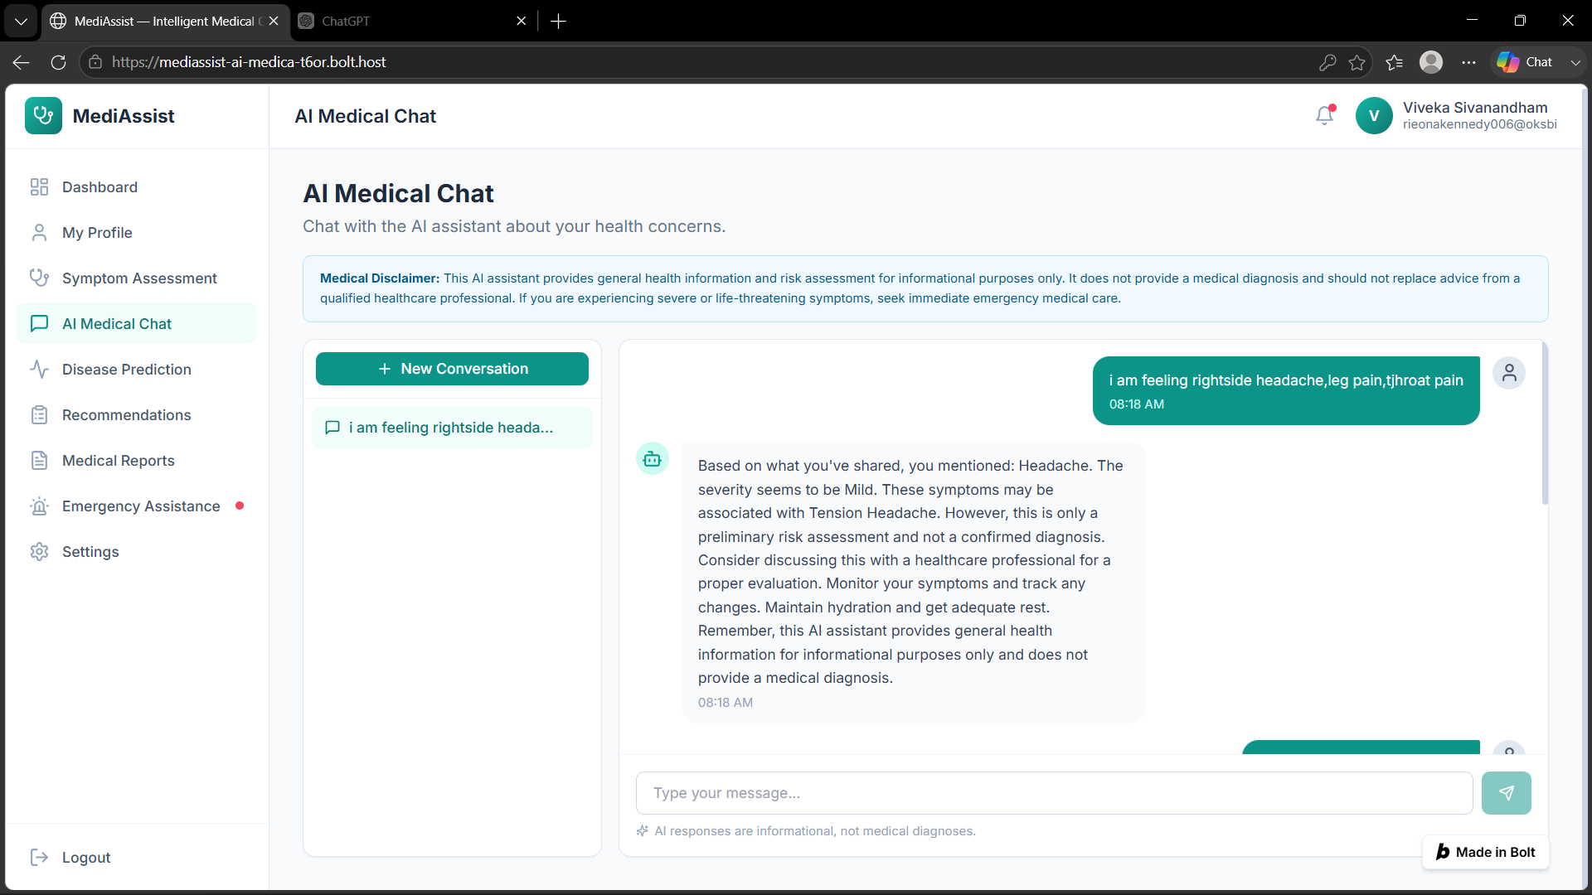
Module 3 – LLM-Based Medical Chatbot

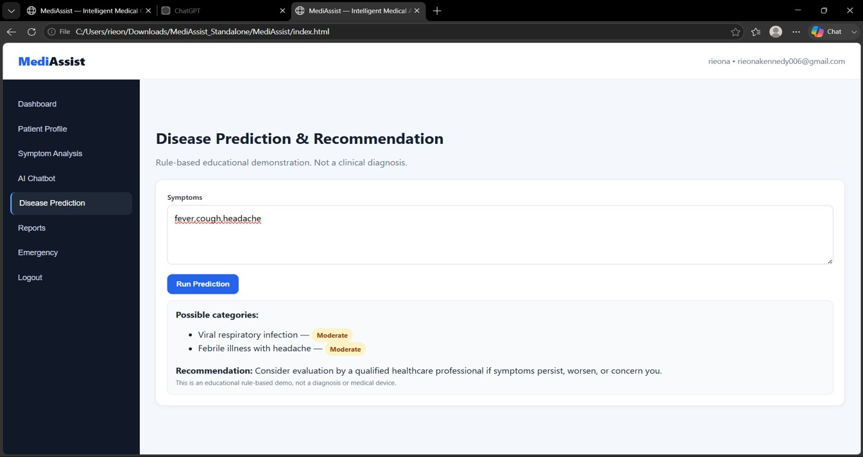
Module 4 – Disease Prediction & Recommendation Engine
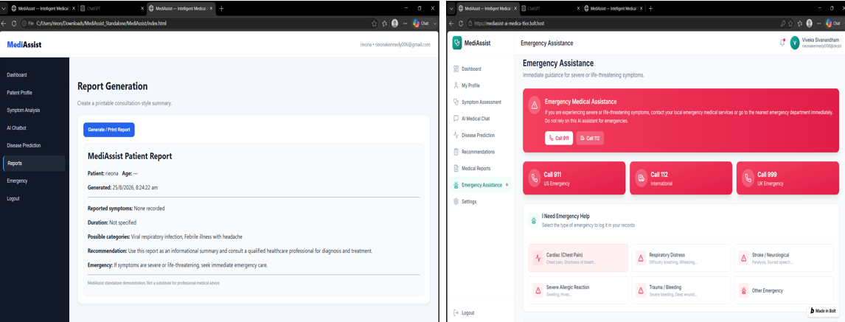
Module 5 – Report Generation & Emergency Assistance

Appendix D – Sample Conversation Evaluation
User Query Type | Expected Behaviour
General health question | Provide general medical information.
Symptom-based query | Predict possible diseases and provide healthcare guidance.
Specialist recommendation | Recommend an appropriate medical specialist.
High-risk symptoms | Advise immediate medical attention.
Follow-up question | Use previous conversation context to generate a relevant response.

Appendix E – Ethics / Institutional Approval

This academic project demonstrates the use of Natural Language Processing (NLP), Large Language Models (LLMs), and Machine Learning for developing an intelligent medical chatbot with a Disease Prediction & Recommendation Engine. The system is designed only for educational and informational purposes and does not replace professional medical advice, clinical diagnosis, or treatment. No claims regarding clinical validation or regulatory approval are made in this project.

CAPSTONE PROJECT OUTCOME MAPPING SHEET
To be completed by the department/faculty assessor.
Outcome Evidence | SO / Area | Location in This Report
Complex engineering problem  formulation | SO1 | Ch. 1, Ch. 2
Engineering design under constraints | SO2 | Ch. 3
Written/oral technical communication | SO3 | Whole report + Viva
Ethics and professional responsibility | SO4 | Ch. 3 (3.7)
Teamwork and leadership | SO5 | Ch. 4 (4.8)
Experimentation, analysis, engineering  judgment | SO6 | Ch. 4 (4.3–4.6)
Independent acquisition of new  knowledge | SO7 | Ch. 5 (5.3)
Standards | SO2 | Ch. 3 (3.2)
Sustainability and  societal/environmental impact | SO2/SO4 | Ch. 3 (3.7)
Risk assessment and mitigation | SO2/SO4 | Ch. 3 (3.7)
Security considerations | Relevant SO | Ch. 3 (3.7)
Integrated/system-level engineering | SO1/SO2 | Ch. 3 (3.5)
Project planning and management | SO5 | Ch. 4 (4.8)
Individual contribution | SO1–SO7 | Contribution Statement + Ch. 4  (4.8)

